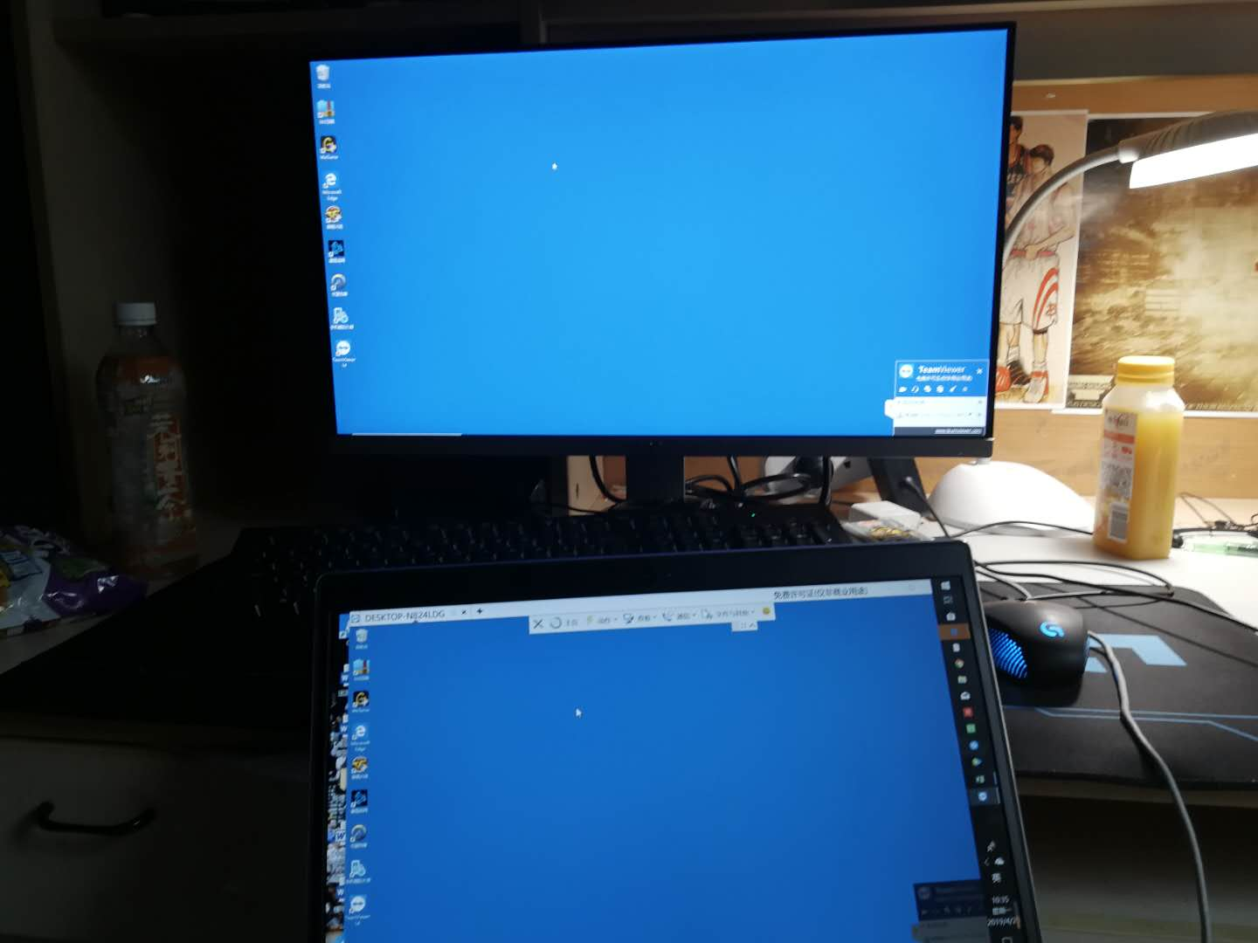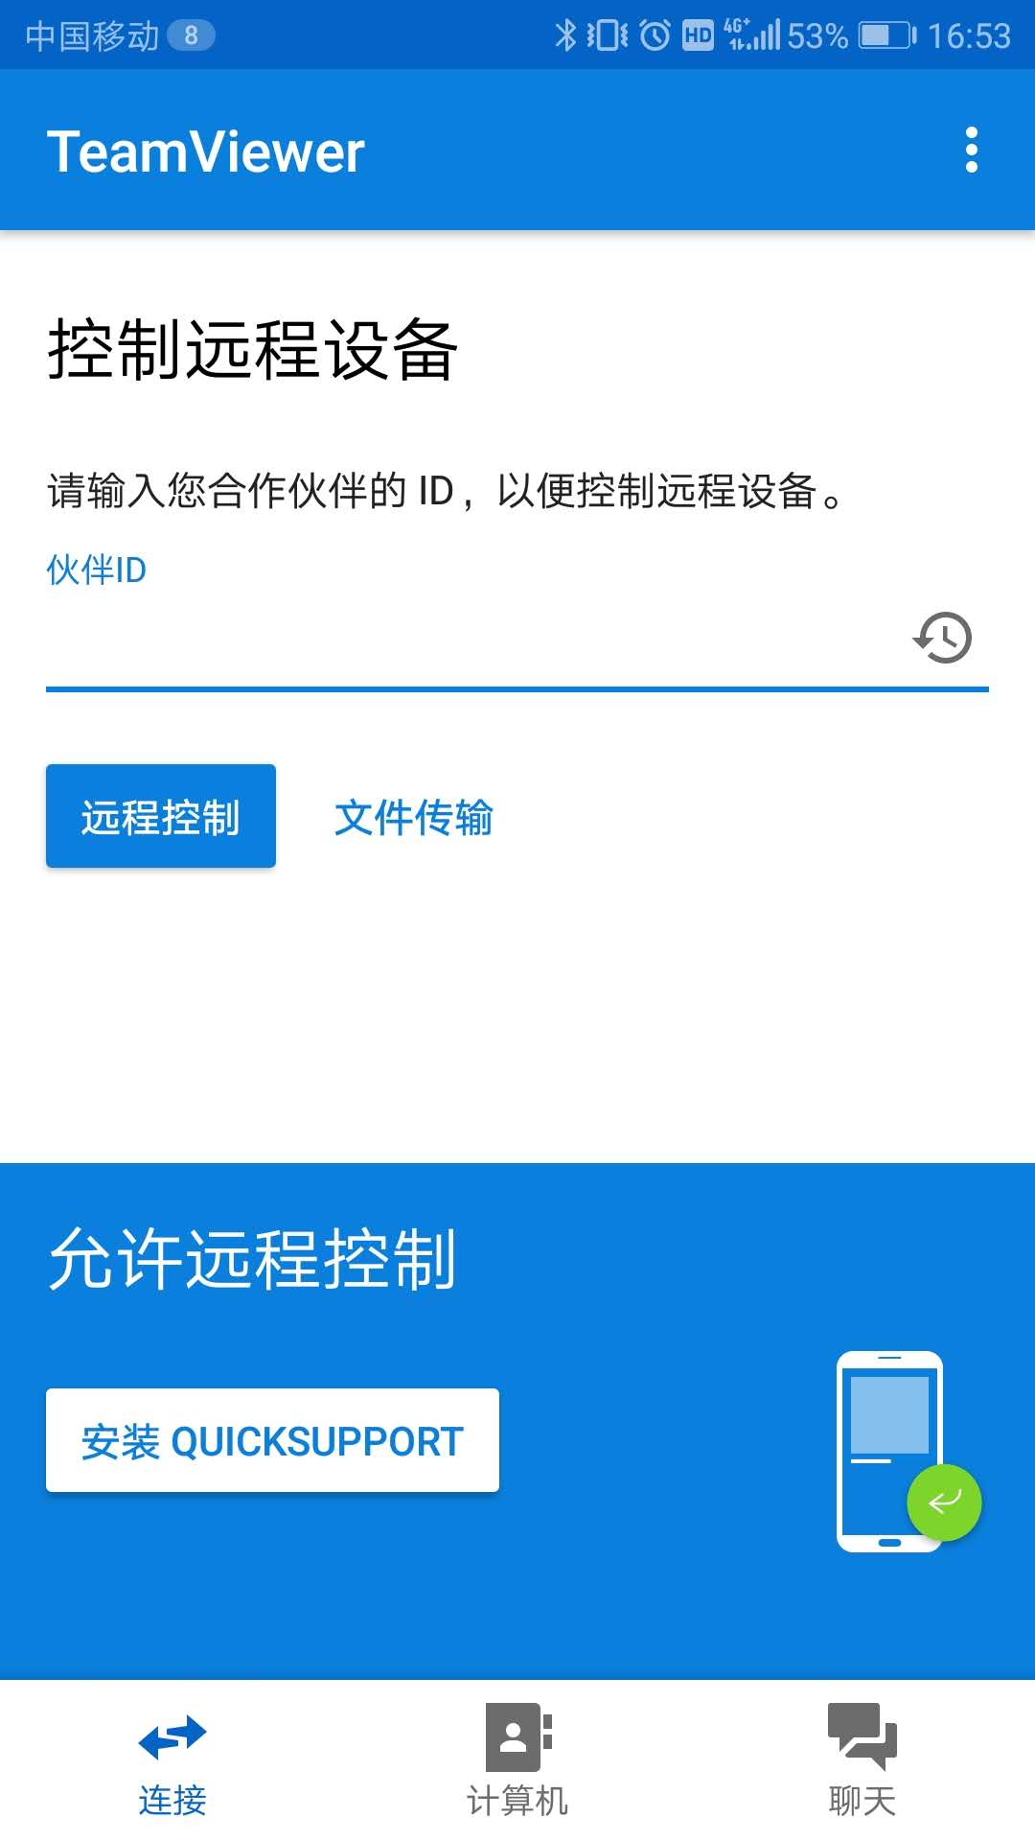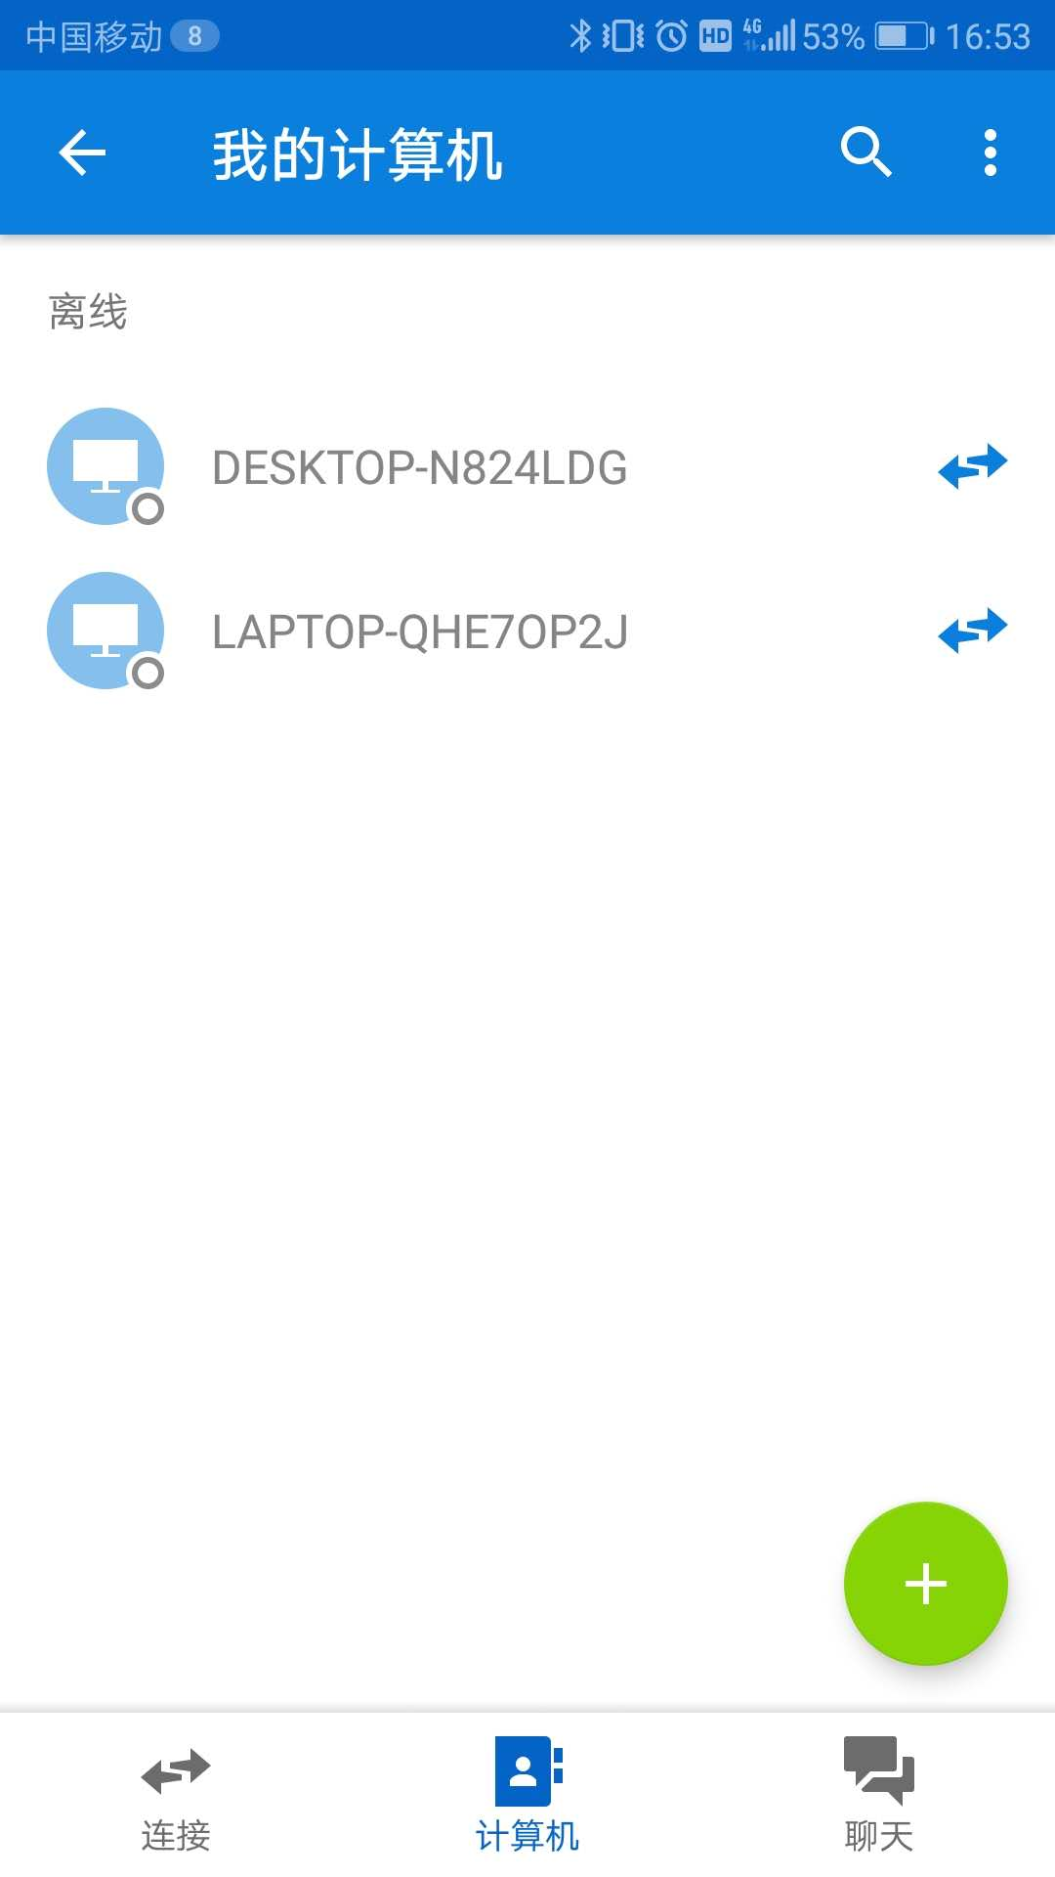
Uncle C:
[图片]

Uncle C:
[图片]

Uncle C:
[图片]

重来:
收到

Uncle C:
这个是我装的teamviewer

